Dokumentasi IoT PLUS

[ESP32 connect to wifi network - how to connect ESP32 to wifi network](https://www.youtube.com/watch?v=I5UL10T0jek)

[ESP32 Firebase Tutorial, Setup Google Firebase account, Send Sensor Data to Firebase Database, IoT](https://www.youtube.com/watch?v=jpYPIh8C_sM)

[How to Make a Button Open a New Activity - Android Studio Tutorial](https://www.youtube.com/watch?v=bgIUdb-7Rqo)

[Cara Membuat Splash Screen Menggunakan Android Studio](https://www.youtube.com/watch?v=H4mCD6s_WrA)

[Tutorial Firebase Realtime Database Kontrol Lampu LED pada ESP32 & Install Firebase ESP32](https://www.youtube.com/watch?v=pbZ6_u4gc6c)

[How to Open an Activity from a Notification - Android Studio Tutorial](https://www.youtube.com/watch?v=j6kQ9gikU-A)

[Firebase data to RecyclerView | How to retrieve firebase data into recyclerview](https://www.youtube.com/watch?v=sZ8D1-hNeWo)

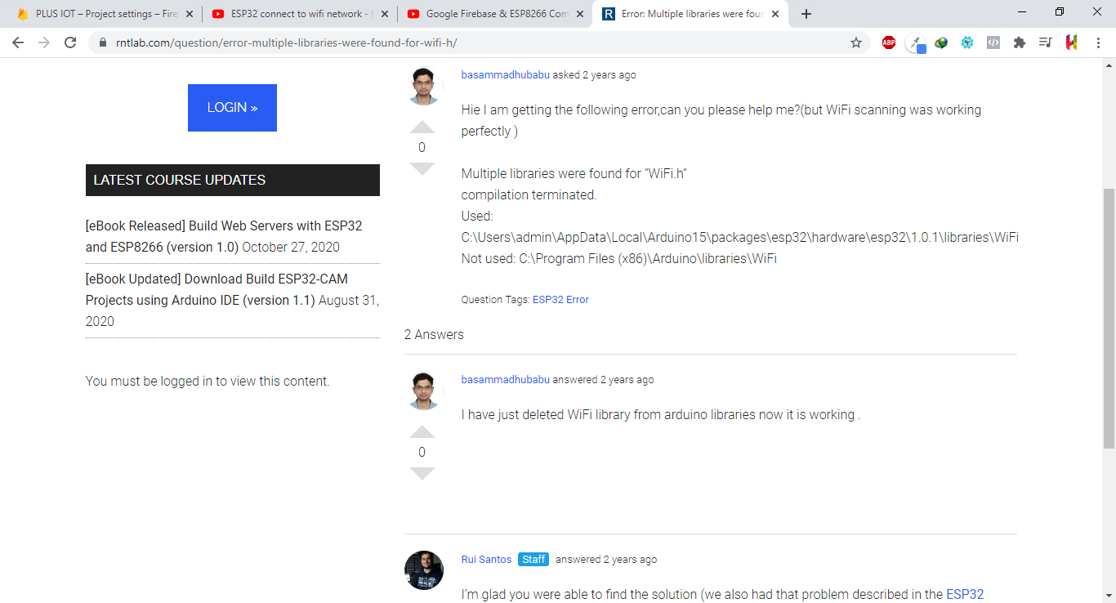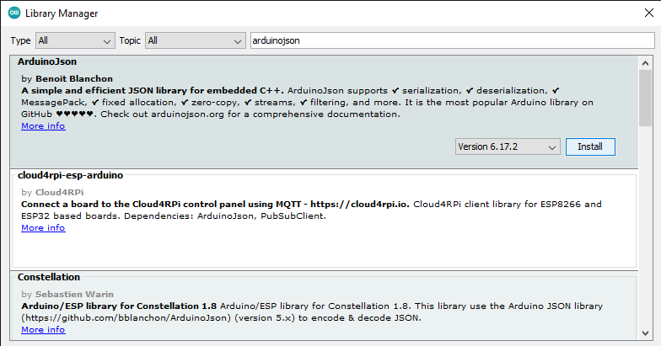

error recycler view

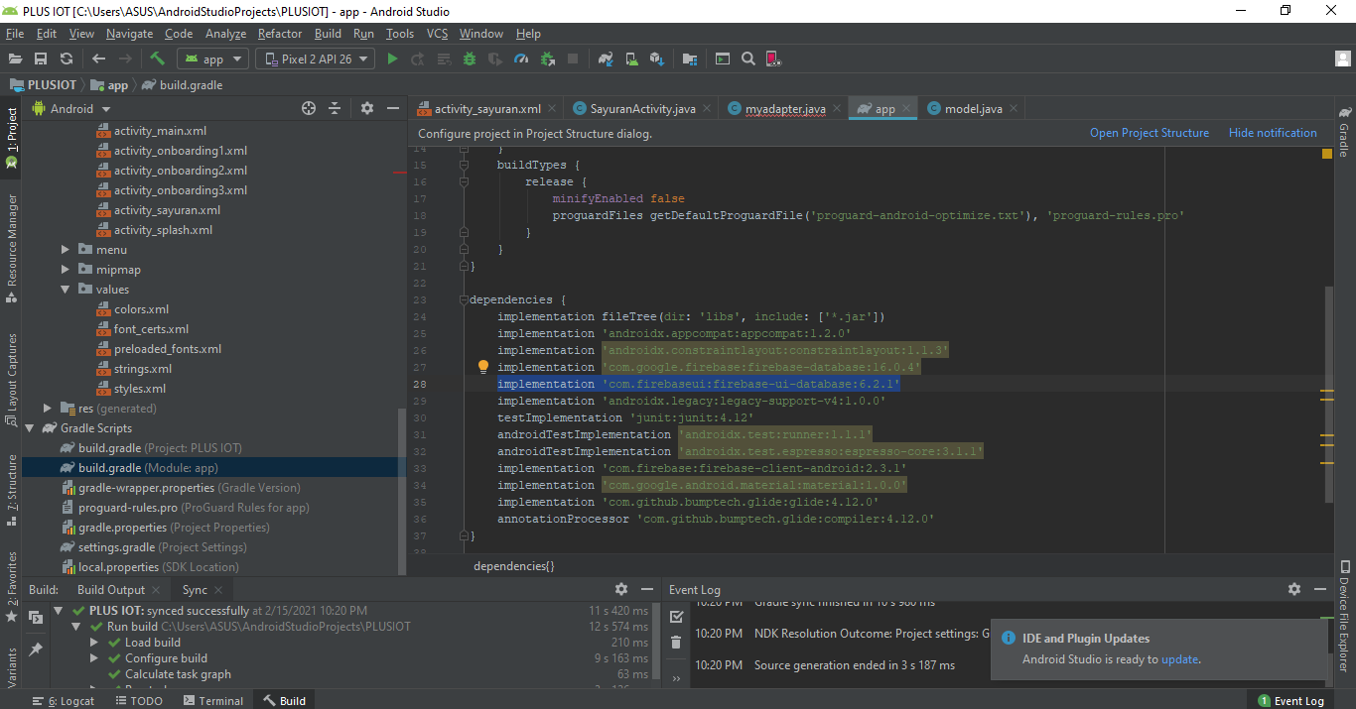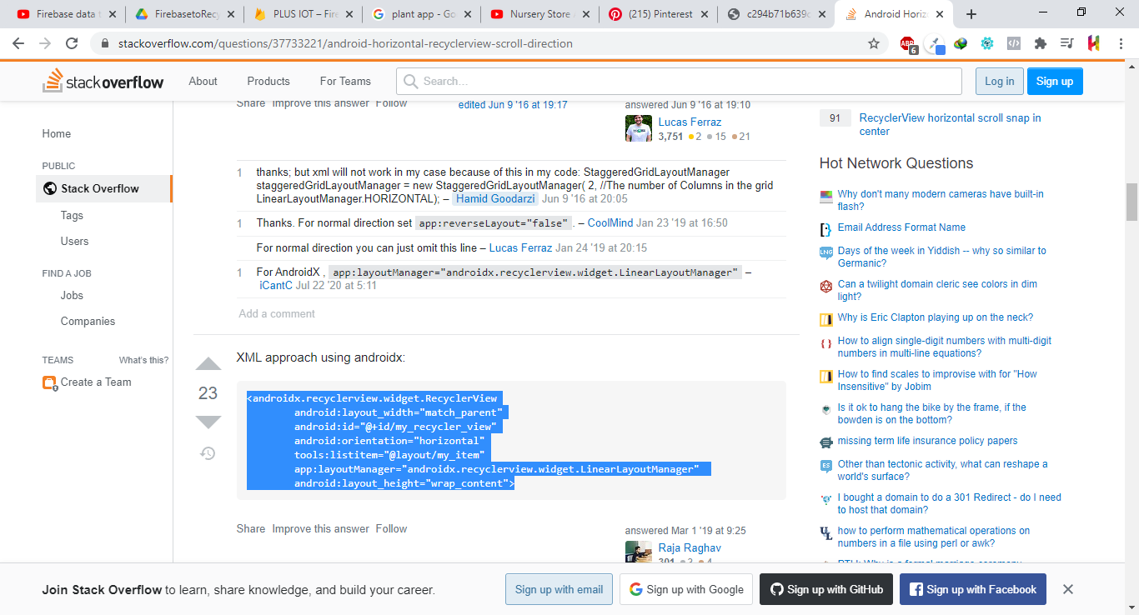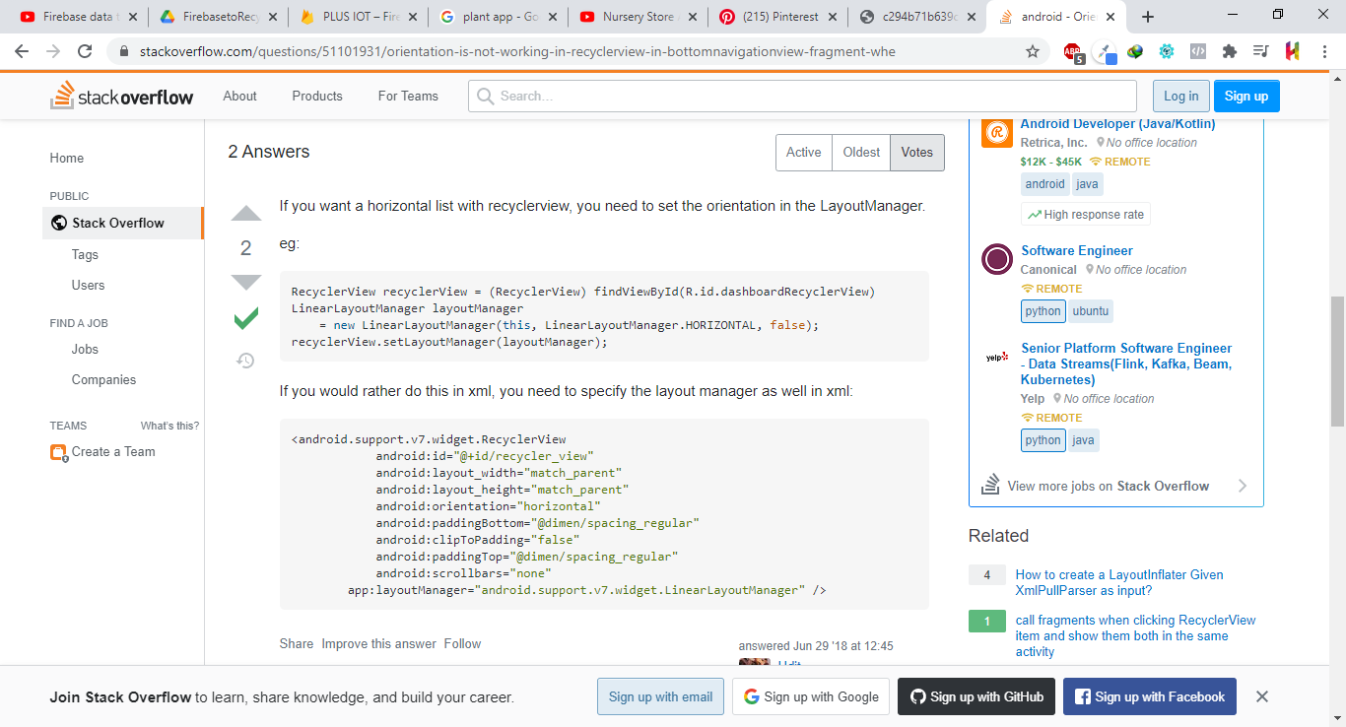

Error DocumentSnapshot (symbol not ...)

implementation 'com.firebaseui:firebase-ui-firestore:3.2.2'